8.14: The impluse imparted to the player is opposite in direction but of the same magnitude as that imparted to the puck, so the player’s speed is 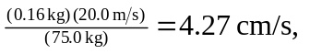in the direction opposite to the puck’s.

